CS 255 System Design Document Template

UML Diagrams

UML Use Case Diagram

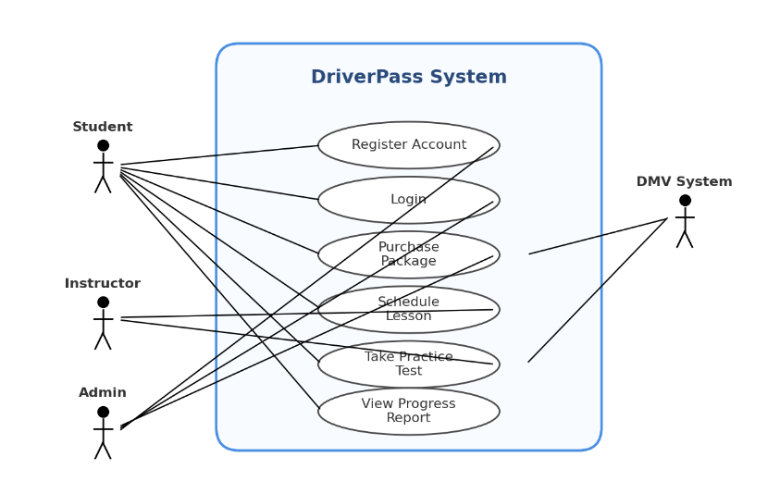

UML Activity Diagrams

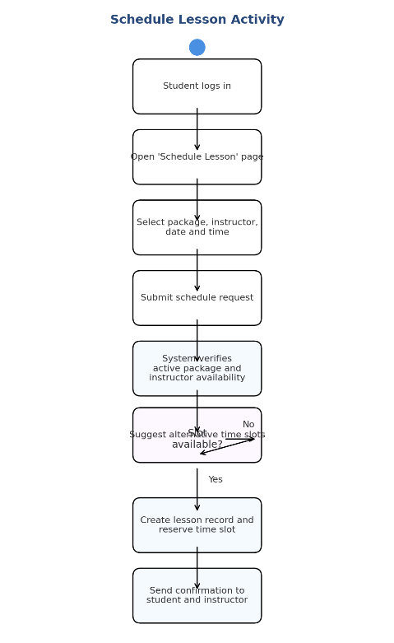

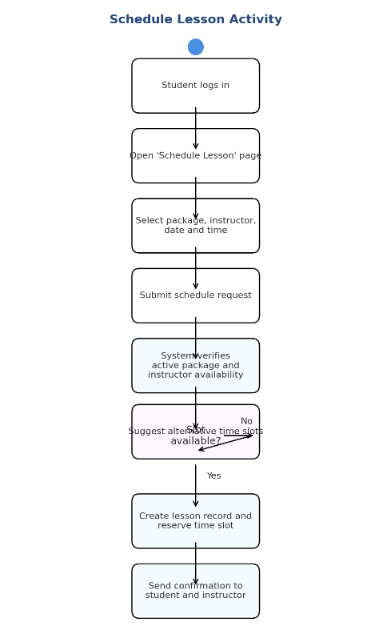

UML Sequence Diagram

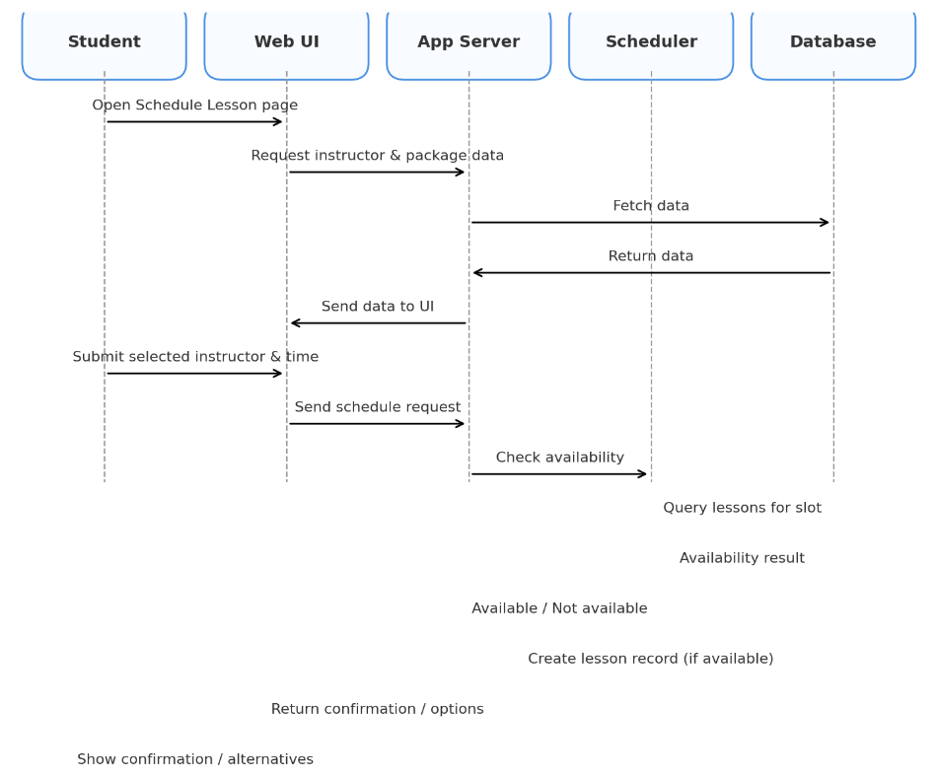

UML Class Diagram

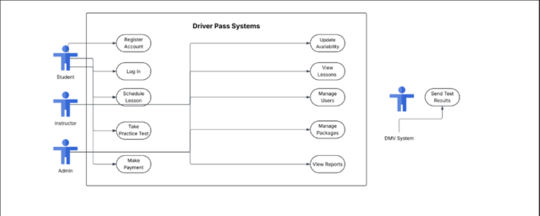

Technical Requirements

The DriverPass system necessitates a modern, secure, and scalable technical infrastructure capable of handling various user roles, database operations, scheduling tasks, and online practice tests. The system will be a web-based application that must function properly on cloud or on-premise hosting.

Hardware Requirements

- Minimum of 4 vCPU server (cloud-based or physical hardware)
- At least 16 GB RAM to handle numerous concurrent users.
- SSD storage for quick database queries and lesson planning.
- Reliable network connection with a 99.9% uptime.
- Backup storage device or a cloud backup option for disaster recovery.

Software Requirements

- Server Operating System:

Ubuntu Server 22.04+ and Windows Server 2019+

- Web technology:

HTML5, CSS, and JavaScript for client-side interaction.

A backend framework like Python Flask, Java Spring, or Node.js

- Supported web browsers:

Google Chrome, Firefox (latest), Microsoft Edge, and Safari

- Database System:

Use MySQL or PostgreSQL to store users, lessons, packages, and test results.

- Test and development tools:

Lucidchart (for System Modeling)

Git/GitHub for version control.

Visual Studio Code and IntelliJ for development

Infrastructure Requirements

- Secure HTTPS connection with TLS encryption for all data transfers.
- Role-based access management for students, instructors, administrators, and DMV integration.
- Centralized authentication service with password hashing.
- Automatic data syncing with DMV records to update testing content
- API layer for real-time updates on instructor availability, scheduling, and student progress.
- Logging and monitoring system for tracking mistakes, login attempts, and administrative changes.

Security Requirements

- Password hashing (e.g., bcrypt or PBKDF2)

- Multi-attempt login protection:

- User accounts should lock after 5 failed login attempts

- Regular automatic backups of the database

- Firewall configuration to protect server endpoints

- Access control policies restricting admin-level functions

- Input validation to prevent SQL injection and cross-site scripting

- Secure handling of personal information according to privacy standards

Scalability Requirements

- Ability to increase server resources as the user base expands.

- Database indexing to accelerate scheduling and test retrieval.

- Load balancing capability when system consumption is high.

